**Image Analysis and Computer Vision**

**User manual**

**Mohanad Diab**

**10769366**

**Directory structure:**

As can be seen in the figure below, the directory has 3 main parts, the general hand detector, the hand distance geometry, and the unity modules.

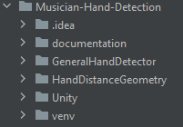Each module has a specific task that will be clarified below with the inputs and the outputs and how to walk through each script to produce the expected outcome.

Figure (1): Directory structure

**General Hand Detector:**

Inside this directory is a module that implements the Mediapipe model with Opencv, to run the Main.py script, inside there are different options under the name “video”, which is a variable that can be commented and un-commented to choose the type of video that one might want to view, the video options are:

1. Piano
2. Accordion
3. Guitar
4. Hands
5. 0 (which is the live video)

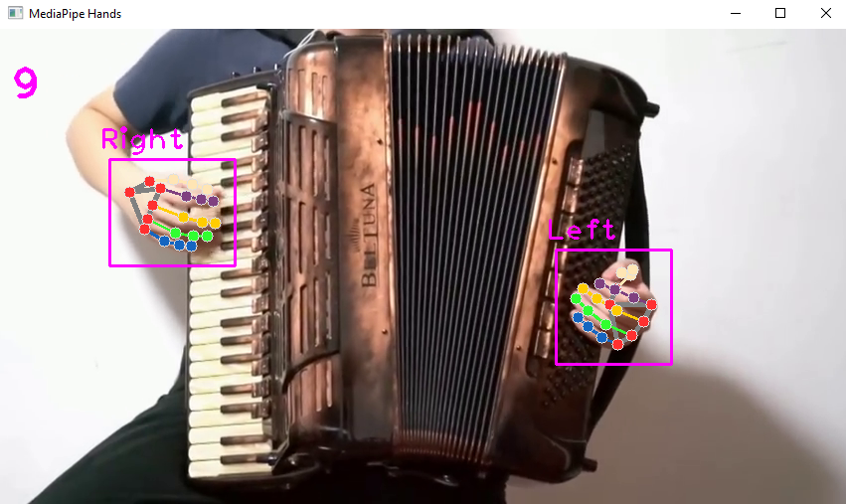In the Main.py script an object is created from the hand detection class, it takes as input the video and the Boolean edges, which shows the edge detection in case of True.

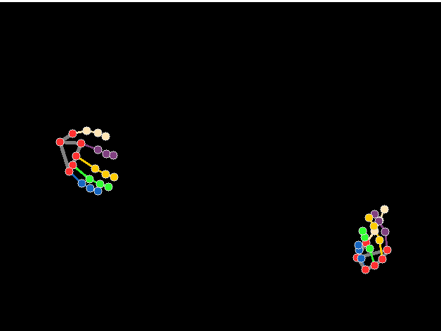

Figure (2): General hand detector and isolated view output

**Hand distance Geometry:**

This part of the script is what actually can be run to obtain the results required by the project, there are 4 variations to the script:

1. HandDetectionGemoetry.py: this script can be run to obtain a live feed to measure the accuracy of the palm plane depth detection algorithm.
2. HandDetectionGeometryIndex.py: this script can be run to obtain a live feed to measure the accuracy of the articulations depth detection of the index finger.
3. DepthDetectionHand.py: this script can be run to obtain a live feed to output the articulations of all fingers, the output is stored in a text file in the same directory.
4. DepthDetectionPiano.py: this script does the same as the script in point 3 but on a 30 second video of a musician playing the piano

One only needs to run the script to achieve the results.

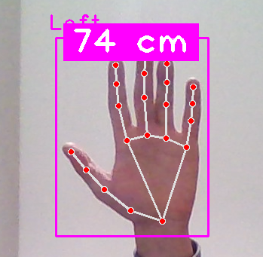

Figure (3): HandDetectionGemoetry.py example

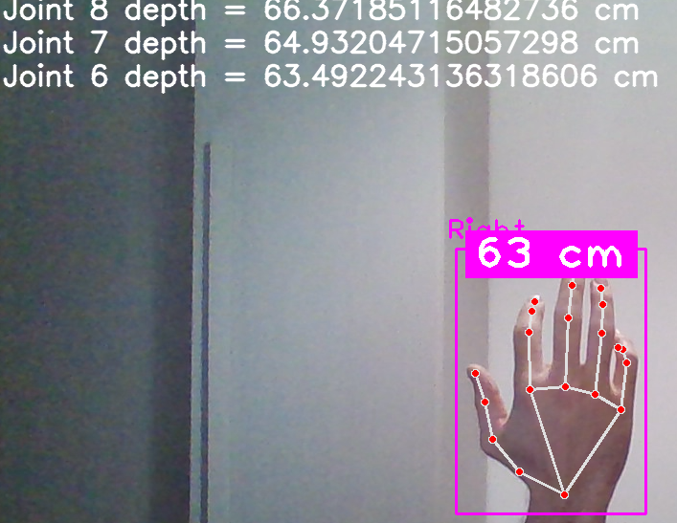

Figure (4): HandDetectionGeometryIndex.py example

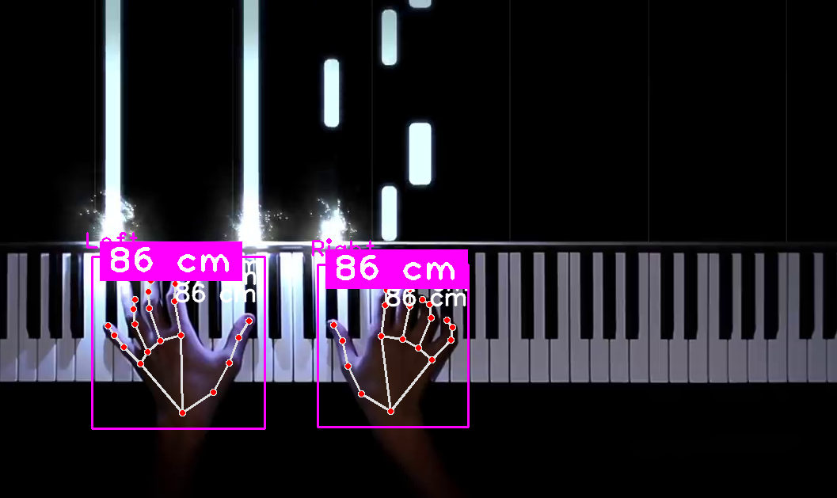Figure (5): DepthDetectionPiano.py example

**Unity Hand Detector:**

This part has only one script that can be run to broadcast the coordinates of the joints of the hand through a socket that cab be listened to by the Unity project that is present in the same directory, the Unity project is already set up, no modifications needed, unless the user is already using the same port number that the socket is using, then one can use any other socket port that they wish, it must be changed in both the script and in the unity manager component. A picture containing shape

Figure (6): Unity example

**Notes:**

All the code provided is commented line by line and is uploaded on my GitHub account and can be found in this link:

[MohanadDiab/Musician-Hand-Detection (github.com)](https://github.com/MohanadDiab/Musician-Hand-Detection)

For enquiries and issues in the implementation of the script contact me through my Polimi account:

mohanadyousef.diab@mail.polimi.it